MonpuraUHC devlopment- unique example of role of a leadership and good governance quality of a leader.

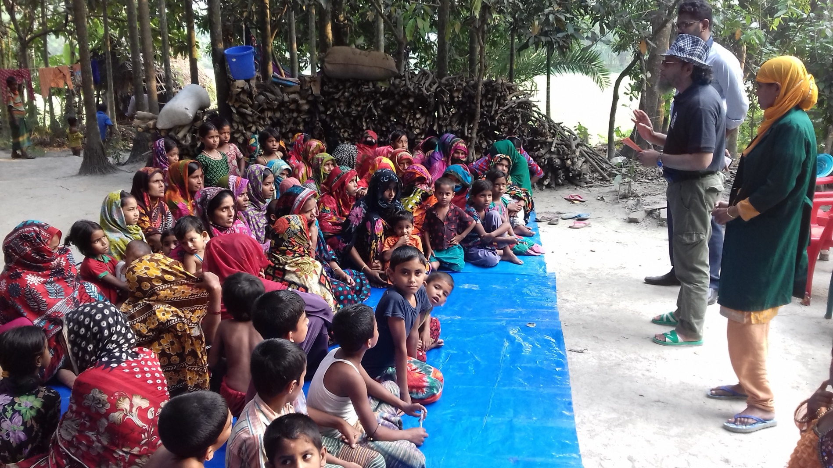
Dr.Mahmudur Rasid UH&FPO Monpura addressing the community in a Othan Boithok.
Monpura an isolated hard to reach Island of Bangladesh situated near Bay of Bangle. 25000 people out of 30000 died by severe cyclonic tidal wave in November 1970 . Monpura is surrounded by the basin of mighty river the Magna.Manpura Upazilla is nearly 10 km awaya directly from main land. Monpura is 8o km south from Bhola head quarter and it takes about six hour to reach Monpura from Bhola through the River Magna. Though its natural beauty and many kinds of fish attract tourists for moments but those who are forced to serve various departments of governments they find difficult to carry their job here as people think that their posting here is for punishment. Isolation from family, trouble in transport, poor living facilities many government employee remain absent from their duty station for long time. As a result there is no significant Improvement in every sectors including health department of Monpura. Before 2016 the health system of Monpura was under dark absenteeism of health workforces and corruption-help newsmen to produce bad news about Monpura Health services both in local and national news papers. Higher officials of health were embraced by that news but those scenario changed once the beauty of governance and community engagement has established. Since 2016 Monpura health service becomes an example for health professional and health policy maker. You may ask yourself how it is possible. the answer is simple and easy to all- good governance and community participation' .
Dr.Mahmudur Rasid UH&FPO of Monpura said “When I was being chosen as a health manager of Monpura Health Complex I was then a medical officer of a health complex named Lalmohan. My Job was to give my customer best possible health care. I learned from my customer that giving service to them is not a duty of a doctor. Doctor should have both sympathy and empathy. In 2016 initially there was mismanagement in everywhere of hospital and in field level. Shortage of manpower and logistics did not make me fragile. I was so determined that with this limited resources. I will do my best. My cleaners, my peons, my office staffs, doctors, nurses, field staffs and CHCS's became my brothers, my friends. My colleges begging to love me and trust me. They changed their minds and realized that what I do form sunrise to sunset is not for me it is for people.” They started a mission "man should not die without a kind touch of a doctor" To make their mission success they first make contact with local government as well as political leaders, media men, teachers, students, farmers, business men and fishermen. They held several health dialogues with the help of SHARE project of ICDDRD where all level of people gave their valuable opinion. They make local body named "community Support Committee" chair by their upazila Parished chairman and fund of taka four hundred thousand was created. One hundred people were assisted by this fund in there critical moments of life 95% of them were pregnant women who need urgent treatment in Bhola district hospital. Prevention and health promotion was another activity. As most of Monpura people are illiterate so somehow they should know health massages and should take prevention measure of diseases. We arranged kobi Gan in public places, patho shova, Uthan Baithok, Shasuri Shomabes and organized school health program. We aware the community about safe delivery, neonatal care, nutrition, non communicable disease prevention and to sick their primary health care from community clinic. We advocate Imams and village doctor to serve as community health volunteers.
Monpuira health Service first address their need for water transport for every people who live in nearby chars Isolated from Monpura.
Now all chars of Monpura get service through Water Ambulance.
On an average every year two severe cyclonic storms run over Monpura. This natural disaster cannot break the mantel strength and unity of our staffs. The number of maternal death reduced to half within two years from 1916 to 1918. Government has declared sixteen Haor Char and Dip Upazila's as hard to reach Upazila as there need special attention for achievement of SDG. Those Upazila are Itna, Mithamain, Ostogram, Sandip, Kutubdia, Hatia, Chouhali, Rowmari, Char Razibpur, Rangabali, Monpura, Darmapasha, Salla, Doarabazar, Azmirigang and Khaliajuri.
People are getting services for their hypertension, diabetes, stoke and many other Disease without any delay form Monpura Health Complex and in Community Clinic.
As the numbers of doctors, nurses and other staffs increased in several folds their retention also increased as a result of community engagement good governance as well as leadership. Dedication and motivation can make any service easy available in slandered way- Monpura has set an example both in plane and had to reach areas of Bangladesh and may be or may not be for other parts of the World.

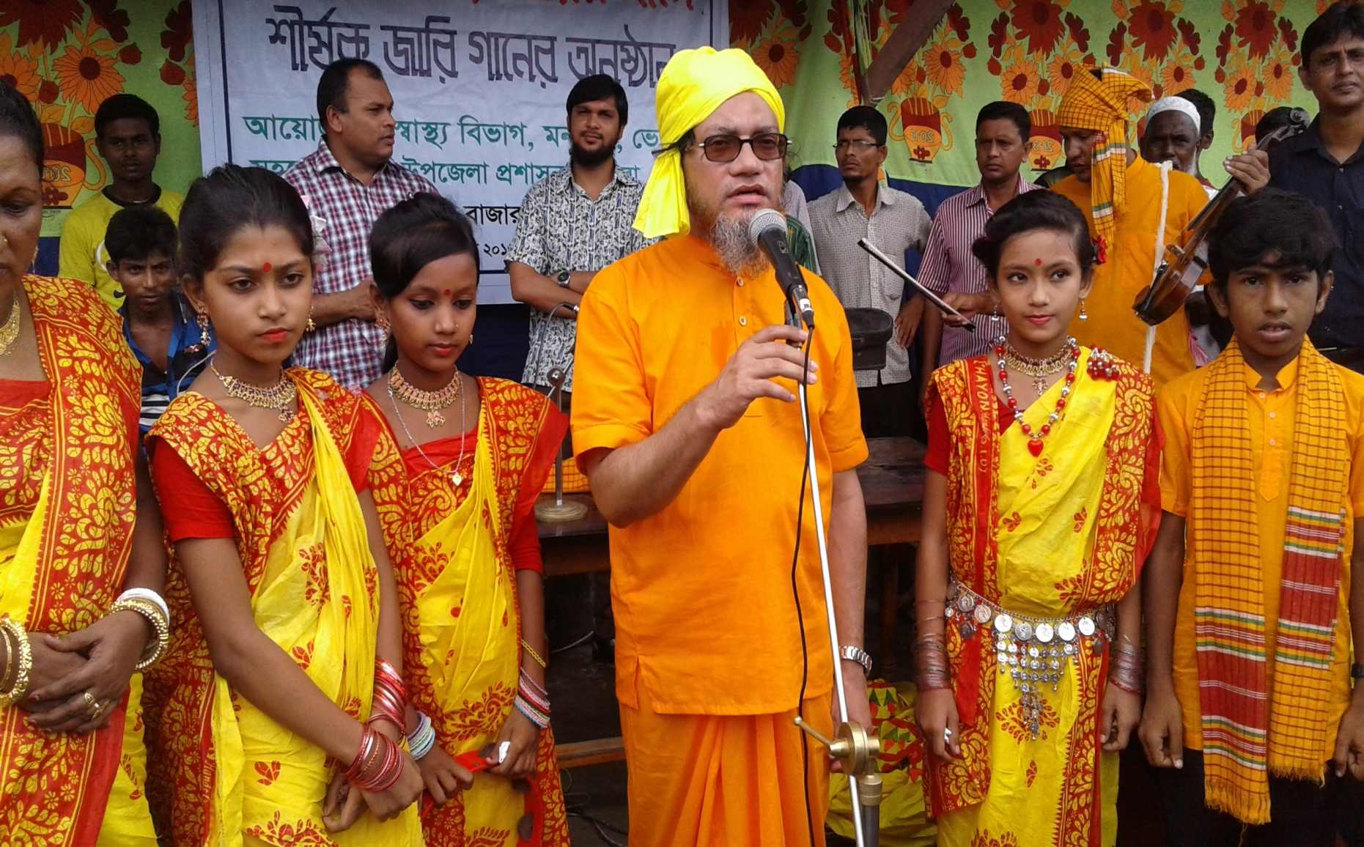
Dr.Mahmudur Rasid addressing the community about health massage by Gari song.

